LED Blink Using ESP32 with Wi-Fi

Description:
The LED Blink Using ESP32 with Wi-Fi project demonstrates how an ESP32 microcontroller can connect to a wireless network and control an LED.
In this project, the ESP32 connects to a Wi-Fi network and hosts a simple web server.
When accessed through a web browser, the server allows the user to turn the LED ON or OFF wirelessly.
This project introduces basic concepts of IoT, Wi-Fi communication, and remote device control.
Block Diagram:
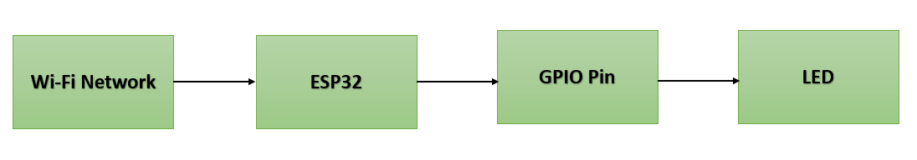

Pinout / Circuit Connection:
- ESP32 GPIO 2 → LED Anode (via 220Ω resistor)
- LED Cathode → GND
- Power Supply → 5V (USB cable to ESP32)

Components Required:
- ESP32 Development Board
- 1 × LED
- 1 × 220Ω Resistor
- Jumper Wires
- Breadboard
- Wi-Fi Network

Working Principle:
The ESP32 has an inbuilt Wi-Fi module.
After connecting to a Wi-Fi network, the ESP32 runs a web server.
When a user accesses the ESP32 IP address through a browser, control commands are sent.
Based on these commands, the ESP32 changes the state of the GPIO pin, causing the LED to turn ON or OFF.
Operation (Step-by-Step):
• Connect the LED to the ESP32 GPIO pin using a resistor
• Upload the Wi-Fi LED control program to the ESP32
• Power ON the ESP32 using a USB cable
• Open the Serial Monitor to note the ESP32 IP address
• Enter the IP address in a web browser
• Click ON/OFF buttons to control the LED wirelessly

Arduino Code:
#include <WiFi.h>
#include <WebServer.h>

const char* ssid = "YOUR_WIFI_NAME";
const char* password = "YOUR_WIFI_PASSWORD";

WebServer server(80);
#define LED_PIN 2

void handleRoot() {
String html = "<h2>ESP32 LED Control</h2>";
html += "<a href=\"/on\"><button>LED ON</button></a><br><br>";
html += "<a href=\"/off\"><button>LED OFF</button></a>";
server.send(200, "text/html", html);
}

void handleOn() {
digitalWrite(LED_PIN, HIGH);
server.send(200, "text/html", "LED ON");
}

void handleOff() {
digitalWrite(LED_PIN, LOW);
server.send(200, "text/html", "LED OFF");
}

void setup() {
Serial.begin(115200);
pinMode(LED_PIN, OUTPUT);

WiFi.begin(ssid, password);
while (WiFi.status() != WL_CONNECTED) {
delay(500);
Serial.print(".");
}

Serial.println("\nWiFi Connected");
Serial.println(WiFi.localIP());

server.on("/", handleRoot);
server.on("/on", handleOn);
server.on("/off", handleOff);
server.begin();
}

void loop() {
server.handleClient();
}

Conclusion: (Predefined/self-written)
The LED Blink Using ESP32 with Wi-Fi project demonstrates wireless control of electronic devices using IoT concepts.
It helps students understand ESP32 Wi-Fi capabilities, web server implementation, and GPIO control.
This project forms the foundation for advanced IoT applications such as smart home automation and remote monitoring.
For Your References:
[1] Espressif Systems, ESP32 Series Datasheet, Espressif Systems Inc., 2016.
[2] Arduino, “WiFi Library for ESP32,” Arduino.cc. [Online]. Available: https://www.arduino.cc/en/Reference/WiFi [Accessed: Jun. 12, 2018].
[3] N. Kolban, Kolban’s Book on ESP32, 1st ed. USA, 2017.
[4] Arduino, “Web Server with ESP32,” Arduino Project Hub, 2019.

